**Handlers:**

* Whenever there is an activity which we want to happen immediately after some action
* This kind of thing is called event
* For this, we need handler

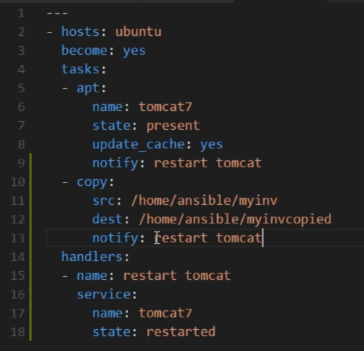

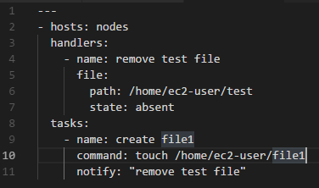

**Giving “ “ in notify is optional. for listen also**

* As above, we no need to write two tasks to restart the service
* We can use notify for handlers
* Handler concept is there in almost every CM tools

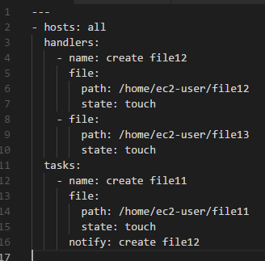

* As above, it creates only file12
* **We can also assign more than one handler for a single task as below**

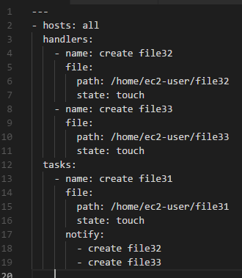

**Listen:**

* As per above example, we use notify with the name of the handler
* Suppose if we want to have one event and multiple handlers for that
* Suppose we want to restart tomcat and apache both. We need to use listen

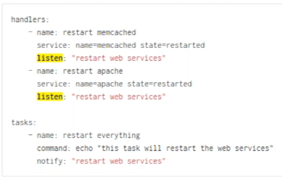

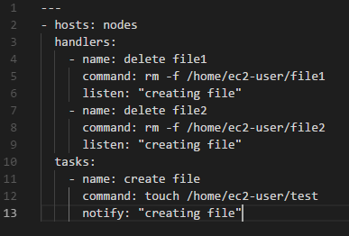

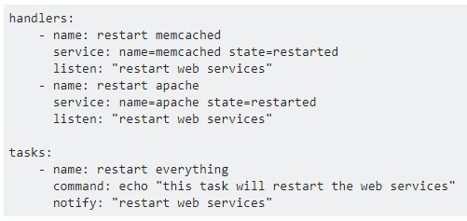

* As per above, we can see two listens referring to same notify. We don’t use this much. We can use it from ansible 2.2
* Here, one source multiple handlers

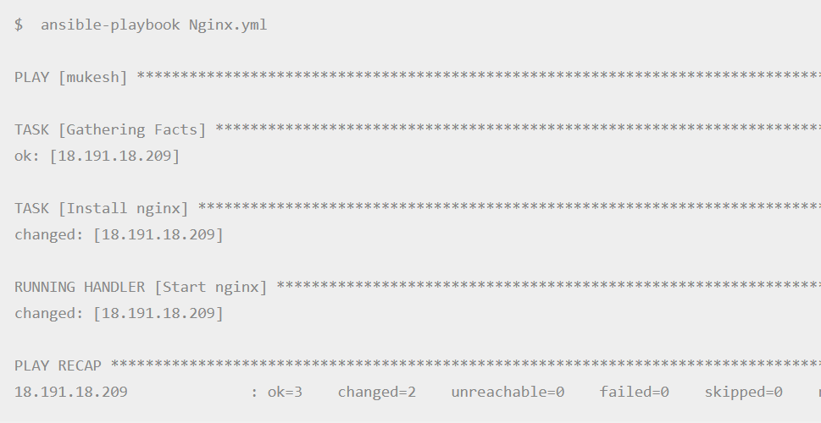

Above is how the handler execution done in ansible.

**Conditions:**

* Conditional statements are expressions

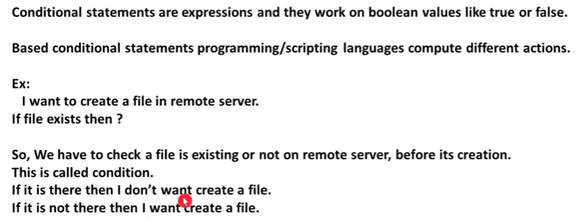

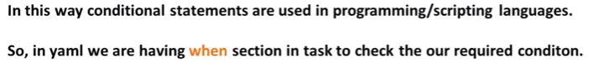

* If we want to run the playbook in a smooth way and if its required we can use when condition. Its optional

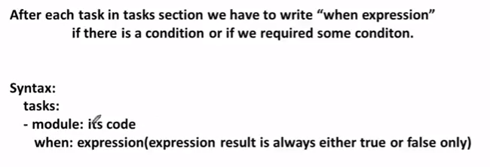

* As above, it will first check the when condition, it that is true then it will execute the task. If not, it will not execute it

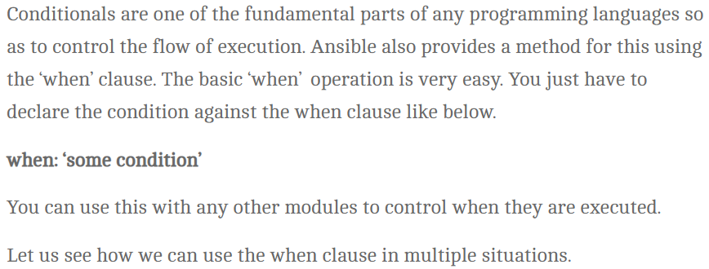

**When file exist:**

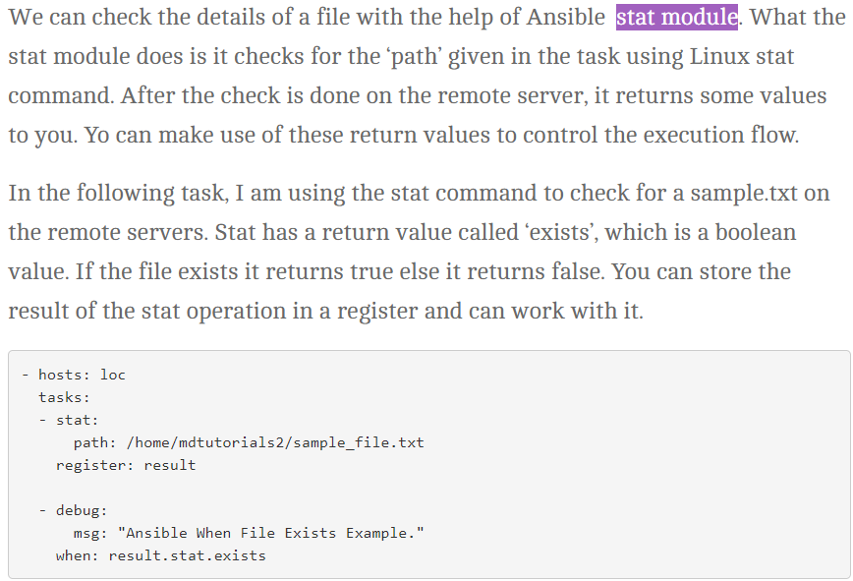

**When file does not exist:**

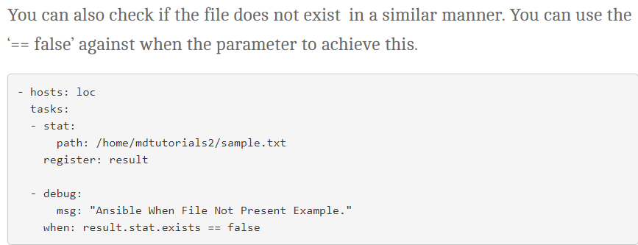

**When directory does not exist:**

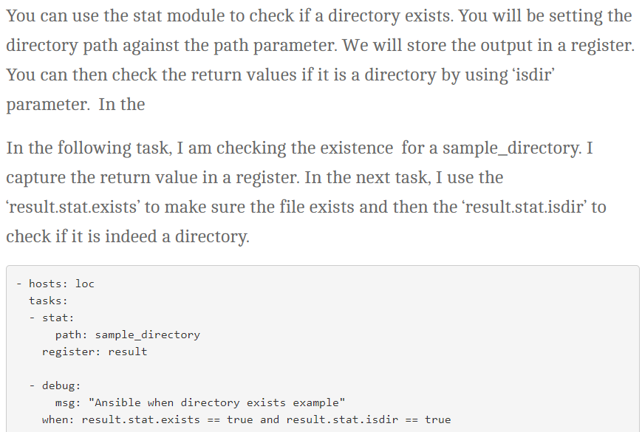

**Ansible when with command module:**

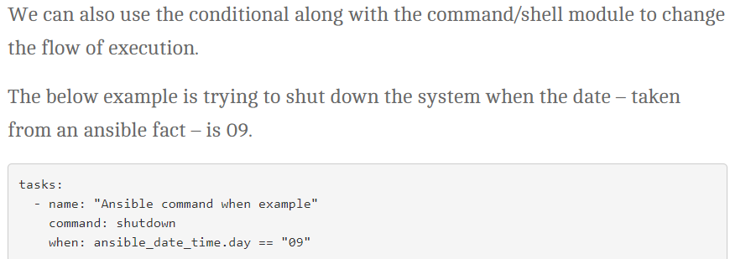

**Conditions based on facts:**

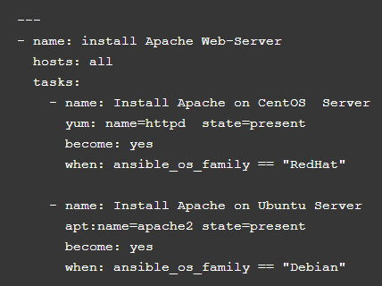

**AND operator:**

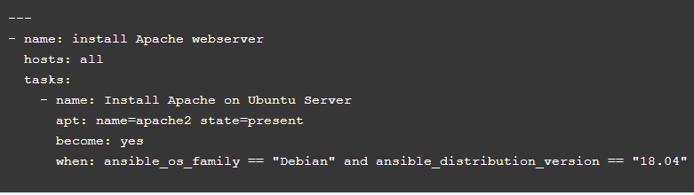

**OR operator:**

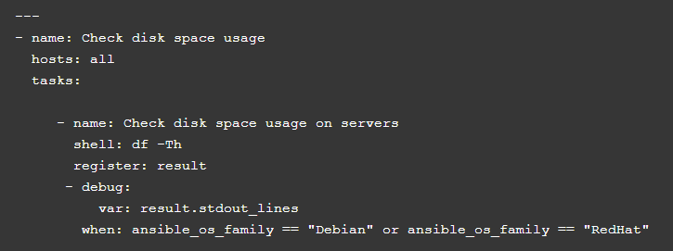

**More examples:**

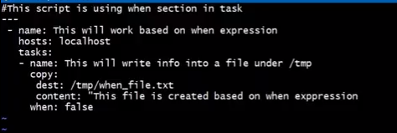

* In yaml file itself, we have given when as false. So, it will skip it
* If we make it true, it will make the changes

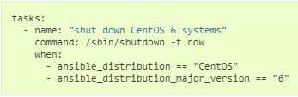

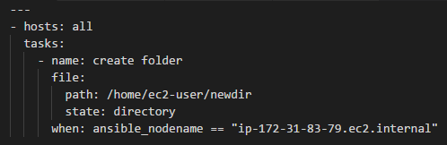

* As above, it will take only the ip address mentioned from the group and skip others

**Loops:**

* Instead of using multiple tasks, we can use loops as below
* We use loops for repeated activity
* Iteration is nothing but loop

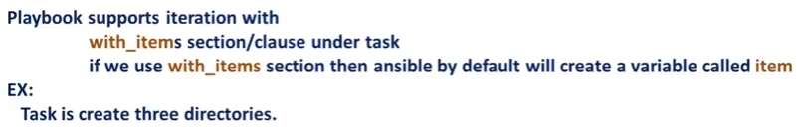

* Without items, it looks like below

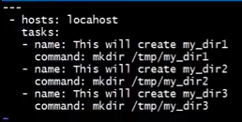

* Below is with items

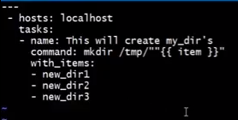

* It runs the command 3 times with items, we no need to write 3 different tasks for that

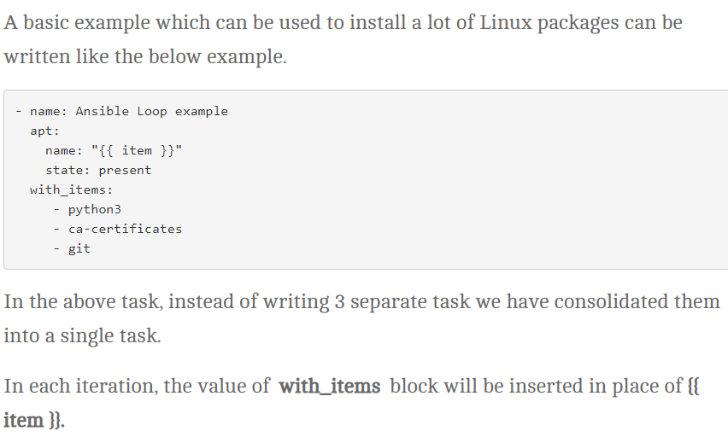

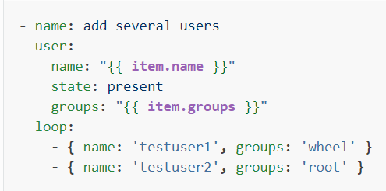

**Loop with index:**

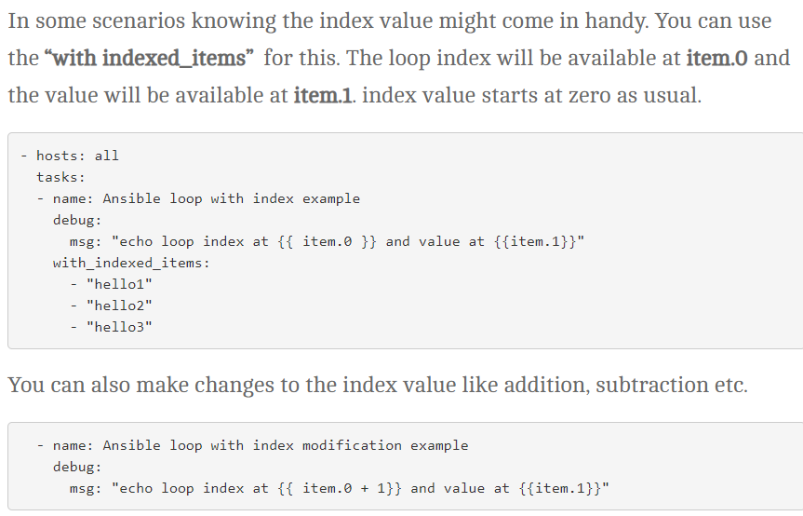

**Loop with condition:**

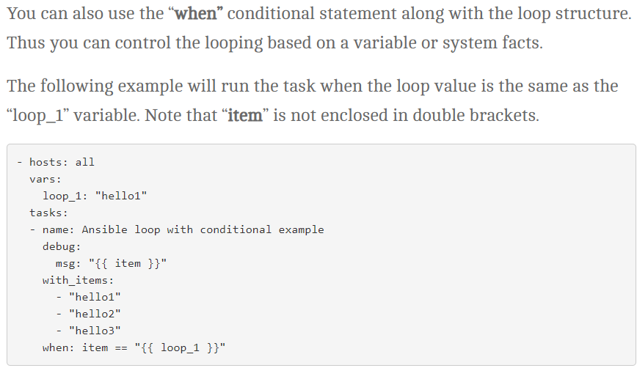

**Condition with system facts:**

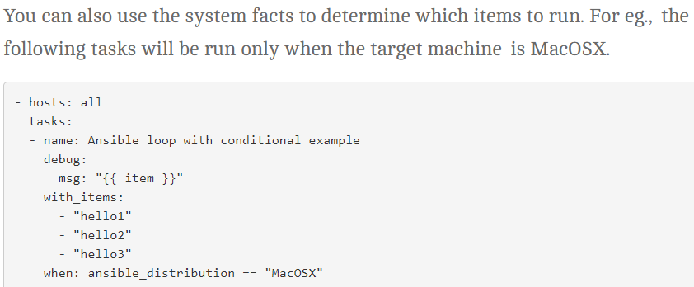

**Another example:**

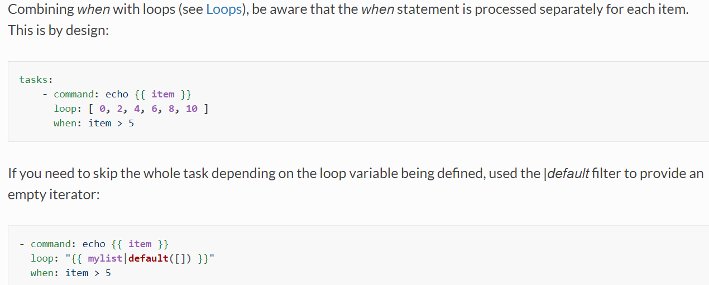

**Few examples:**

